# IG Weekly assessment 1

**OUTPUT:**

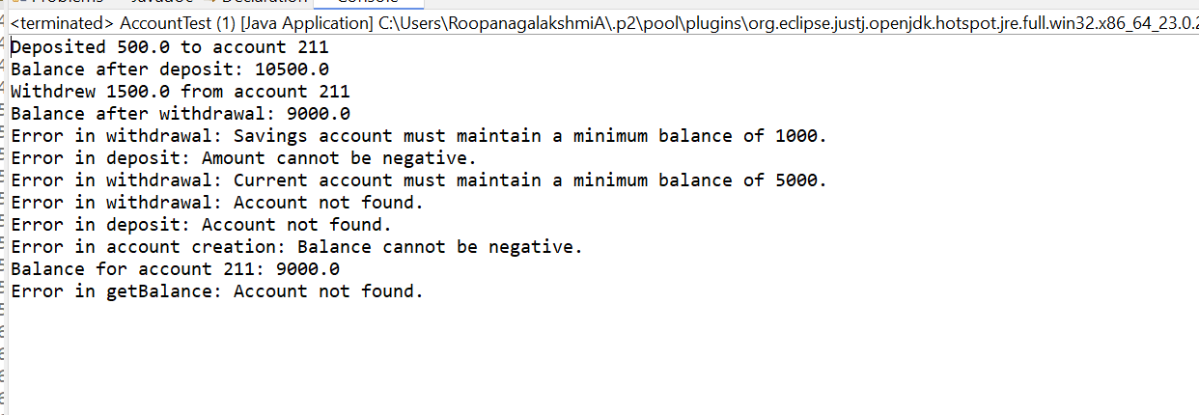

**TEST CASES ON WHICH THE CODE IS TESTED ARE AS FOLLOWS**

1. **Valid Deposit** - gives deposited and balance message

2. **Valid Withdrawa**l - gives withdrawal and balance message

3. **Invalid Withdrawal** - insufficient funds in savings account

4. **Invalid Deposit** - invalid amount

5.**Invalid Withdraw** - insufficient balance for current account

6. **Invalid Withdraw** - non existing account

7. **Invalid Deposit** - non existing account

9. **Valid** **Get balance** - Valid account

10. **Invalid** **Get balance** - non existing account